Mt. Pisgah
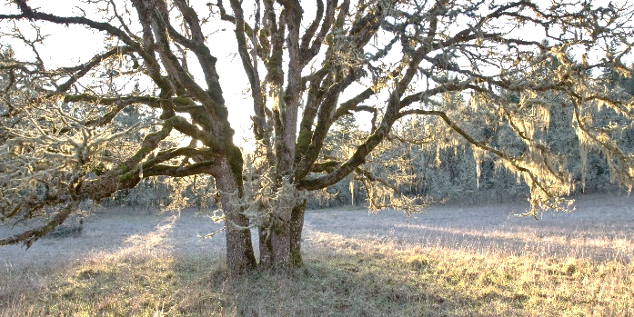
Bird Guide: The Wonderful World of Feathered Friends at the Arboretum

Table of Birds:
Arboretum Entrance …………………………………………………………………….. 4 – 9
- Western Tanager
- Black-headed Grosbeak
- White-breasted Nuthatch
- Brown Creeper
- Hairy Woodpecker
- Downy Woodpecker
Upper Trails…………………………………………………………………………………….. 10 – 14
- Stellar’s Jay
- Red-breasted Nuthatch
- Chestnut-backed Chickadee
- Red Tailed Hawk
- Lazuli Bunting

Miscellaneous………………………………………………………………………………………. 15 – 30
- Tree Swallow
- Pine Siskin
- Pileated Woodpecker
Key:
1 – Riparian Fall – Fall
2 –Low Wetland Win – Winter
3 – Oak Woodland Spr - Spring
4 – Coniferous Sum – Summer
5 – Grassy Slopes

VC – Very Common
C – Common
U - Uncommon

- Violet-green Swallow
- Pacific Wren
- Winter Wren
- Golden-crowned Kinglet
- Ruby-crowned Kinglet
- Cedar Waxwing
- Spotted Towhee
- Dark-eyed Junco
- Song Sparrow
- House Finch
- Black-throated Gray Warbler
- Wilson’s Warbler
- Red-breasted Sapsucker

Assembled by Ryan Mitchell
All resource materials and photos gathered from
allaboutbirds.org through Cornell University

Happy Birding

2017
Western Tanager
Arboretum Entrance
Spring – C Habitats: 3, 4
Piranga ludoviciana
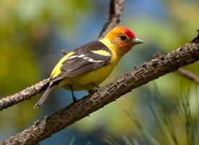
Features of this bird are immediate: a bright yellow body and crimson head. Their beaks are short and have a stocky body build. The wings are black with two wingbars of yellow and white.
This bird finds itself in Western woodlands as well in evergreen canopies.

Photo Credit: Stephen Parsons
Upper Trails

Black-headed Grosbeak
Arboretum Entrance
Spring – VC Habitats: 1, 2, 3, 4
Pheucticus melanocephalus
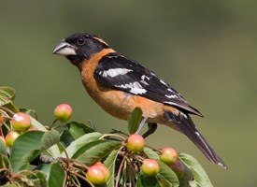
The large, stout beak of the bird leads to a thick neck. The body is a rusty red with black heads and tails. The black-and-white wings have yellow coloring underneath.
The bird can be found all over the United States from the Mississippi west. Its ideal habitat is one of a dense understory containing large trees.

Photo Credit: Ganesh Jayarman

White-breasted Nuthatch
Fall – C Winter – C Spring – C Habitats: 3
Arboretum Entrance
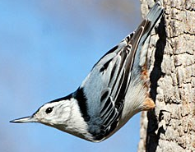
Sitta carolinensis
A long, skinny beak is an easy identifier of this bird. It has a small body leading directly to a large head with almost no visible neck in-between. The coloring of this variant are marked by a muted blue on the back and black hood surrounding the otherwise white feathers.
They are typically found in deciduous forests up against the bark of trees. Often, they stand sideways or upside-down on the tree while they search for food.
Photo Credit: Jim Paris

Brown Creeper
Arboretum Entrance
Fall – C Winter – C Spring – C Habitats: 2, 3, 4
Certhia americana
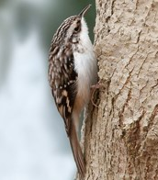
A short bird with a long beak, it could easily be mistaken for a wren or nuthatch. Some features distinguish it though. The upper half is a flecked brown while the belly is white with a long tail. A curved beak is a telltale sign of a brown creeper.
They are found all over woodland areas, evergreen or deciduous, high up in the trees latched onto the trunk, climbing up. Nests are particularly interesting as they use insect cocoons and spider egg cases to bind the various materials of the nest e.g: lichens, moss, feathers, grass and bark.
The creeper eats primarily insects and larvae from the bark of trees starting at the bottom.
Photo Credit: Kelly Colgan Azar

Hairy Woodpecker
Arboretum Entrance
Fall – U Winter – U Spring – U Habitats: 2, 3, 4
Picoides villosus
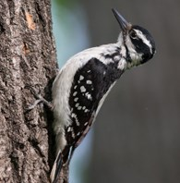
Unlike the downy woodpecker, this species does not have the red crown on its head. Its wings are black with white spots, and the head is striped black and white. Their beak, unlike the Downy Woodpecker is much longer.
A lazy bird, in a way, it will follow the pecking sound of the Pileated Woodpecker and forage for leftover insects in the holes already made. They will also do the same for the sapsuckers, coming later to feast from the pre-drilled wells.
Photo Credit: Christopher L. Wood

Downy Woodpecker
Fall – VC Winter – VC Spring – VC Habitats: 1, 2, 3, 4
Arboretum Entrance
Picoides pubescens
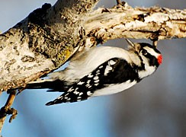
The Downy Woodpecker is colored like the Hairy Woodpecker but has a red spot on the back of its head. The thorn-like bill points out of a black and white striped head which leads down to a white belly and black and white spotted wings. The male of this species is rather controlling, often pushing away the females from the productive smaller branches to the less productive trunk with fewer bugs.
You can find the woodpecker almost anywhere, from the woods to the suburbs. People may mistake the drumming of the woodpecker for feeding habits, but more often than not it is actually their version of a bird call. If you hear and see a Downy Woodpecker drilling loudly, it is probably having a conversation rather than feeding.
Photo Credit: Ron Kube
Steller’s Jay
Upper Trails
Fall – VC Winter – VC Spring – VC Habitats: 3, 4
Cyanocitta stelleri
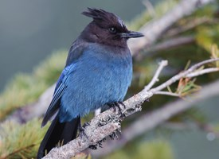
This jay is characterized by a black head and tail and by having a flaring crest. They have been called aggressive birds. Typically, they will raid the nests of other birds for food or nesting materials, sometimes even killing them. While they can be found in many coniferous-deciduous forests, they prefer lower elevations in the Pacific region.
Their diet can consist of pretty much anything they can find, be it nuts, seeds, fruit, insects, and even the trash of human picnics.
Photo Credit: Gerrit Vyn

Red-breasted Nuthatch
Upper Trails
Fall – C Winter – C Spring – C Habitats: 3, 4
Sitta canadensis
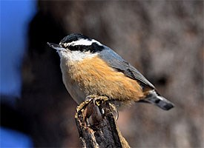
Short tails, a plump chest, stubby neck, and zebra striped head help identify this particular nuthatch. While named for the cinnamon-colored underside, their backs actually have blue-grey accents.
This particular nuthatch has interesting nesting habits. It will collect the resin from coniferous trees to line their nesting holes. During the construction of their nests, they can become extremely aggressive towards nearby birds and even will steal from other birds for materials.
Photo Credit: Aka Heehaw
Their eating habits vary by season. In the summer, insects are the main course; in winter, conifer seeds fill their bellies.
Chestnut-backed Chickadee
Upper Trails
Fall – C Winter – C Spring – C Habitats: 4
Poecile rufescnens
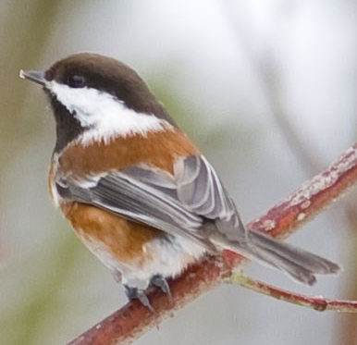
This tiny bird is identified by a white belly, brown back, and a white stripe through their black head. They can be found hanging upside down from cones in the west coast forests.
Their diet primarily consists of insects with few seeds and berries. They can find these foods throughout Pacific woodlands, especially in Douglas Fir and Incense Cedar forests.
Their nests are built mostly with fur of other woodlands creatures like rabbit, coyote, and deer. They do this so that they can cover their eggs with the fur while they are out away from the nest, keeping them warm.
Photo Credit: cdbtx
Red Tailed Hawk
Fall – C Winter – C Spring – C Habitats: 3, 4, 5
Upper Trails
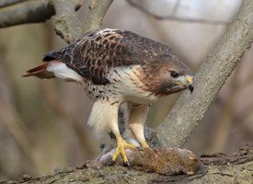
Buteo jamaicensis
Even though this is one the most common hawks that can be found in North America, they can still be difficult to spot. They are found high up in the sky, scanning for their prey such as voles, snakes, and other birds.
Their screech can be heard easily above the murmur of the forest; a high, raspy call piercing through the canopy.
They have an interesting courting routine that involves a series of wide circles, intense dives, and plummeting spirals as the male and female clasp talons.
Photo Credit: Michael Horn
Lazuli Bunting
Upper Trails
Spring – VC Habitats: 3, 5
Passerina amoena
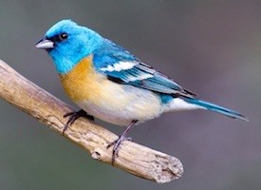
Each of the male birds has his own distinct song. It possible for the younger Buntings to actually copy the older birds in the community creating a “song neighborhood” of one similar song passed down and around.
They are often found in the brush of hillsides and open woodlands, foraging for fruit, seeds, and insects.
Only the male exhibits the brilliant blue coloring shown here. The female has a grey-brown head, neck and back. The backside can be brown with blue tints with wings with tan wingbars. The longer neck and slight crown are conserved between the male and female.
Photo Credit: Keith Alderman
Tree Swallow
Miscellaneous
Spring – VC Habitats: 1, 2, 3
Tachycineta bicolor
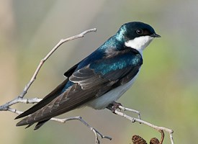
Most noticeable about this swallow is the iridescent blue coloring along the head and shoulders. They have extremely tiny bills that seem to peak out of their heads.
Ironically, they are seen in more open areas unlike their name suggests. They get the name Tree Swallow because of their habit to nest in tree cavities.

Photo Credit: Gerrit Vyn

Violet-green Swallow
Miscellaneous
Spring – VC Habitats: 1, 2, 3
Tachycineta thalassina
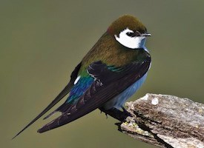
Found only in the American west, the bronze and green bird can be easily mistaken for its lookalike the Tree Swallow. It is the slightly stockier build and white underbelly that extends through the top of the face that identifies this species.

Photo Credit: Bob Gunderson

Pacific Wren
Miscellaneous
Troglodytes pacificus
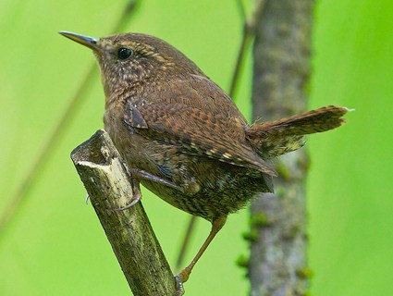
The Pacific Wren is one of the smaller ones in its genus and has darker coloring. With a short upturned tail (characteristic of wrens) and an almost neck-less head, the bird looks like a little ball. They often are found in the understory, foraging for food of insects amongst the fallen trees and upturned roots.
Interestingly, the male of the species will actually make several nests. This is done so he may give a female a “Tour of Homes” so that she may pick out the best nest for her.
Photo Credit: Gary Mueller
Winter Wren
Miscellaneous
Fall – C Winter – C Spring – C Habitats: 2, 3 – Winter 4 - Spring
Troglodytes hiemalis
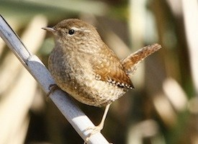
Originally thought to be one species, the collection of Pacific, Winter, and Eurasian Wrens all have the same spry movement and color patterns.
What separates the species is a type of behavioral isolation. This is shown between the Winter and Pacific Wren heavily where the species will cross each other geographically during mating season, with all the males singing. However, because the two species have different songs, the females only choose those of their species. A fun fact about their nesting habits, they will often build multiple nests for roosting or repeated breeding attempts.
Photo Credit: Dwanyejava
Golden-crowned Kinglet
Miscellaneous
Fall – VC Winter – VC Spring – VC Habitats: 4
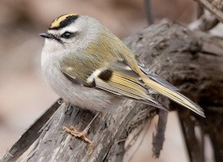
Regulus satrapa
Round bodies, short wings and tails, almost no neck to speak of, and a pointed little bill that protrudes from its head identify this bird. This species has a bright yellow strip down the middle of its head surrounded in black. Their wings have gold as well, with black and white rectangular wingbars.
Their diet consists primarily of insects with the occasional seed. They glean their meals along the branches of trees in the coniferous and
Photo Credit: Kelly Azar
deciduous forests where they reside. The female will lay two broods during a season. The mother feeds the first brood up until they leave the nest, while the second brood is fed almost exclusively by the father.
Ruby-crowned Kinglet
Miscellaneous
Fall – U Winter – C Spring – U Habitats: 4
Regulus calendula
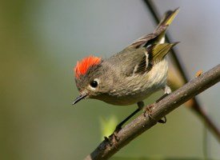
A small bill, short body, and small head identify the Kinglet. The red crown and white eye ring immediately gives it away as a Ruby-Crowned Kinglet. It wings have an interesting, brown, black, and white striated look that contrast greatly against its mundane brown and tan body.
They lay an incredible amount of eggs per clutch, up to 12, that are nested up high in a tree, close the trunk. These birds will grow to eat spiders and all sorts of insects along the branches of the surrounding trees.
Photo Credit: Ken Schneider

Cedar Waxwing
Miscellaneous
Fall – C Winter – C Spring – VC Habitats: 1, 2, 3, 4
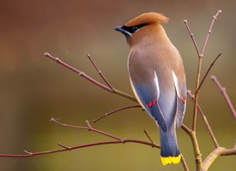
Bombycilla cedrorum
A bit larger than most of the birds on this list, Cedar Waxwing has an incredible color palette that makes it easily identifiable. Starting at the head, a black mask covers the rusty-red head and body, extending through the back of the crown. The lower half is a silky gray with a yellow fringe on the end of their tails. Their wings have bright red droplets along the middle.
Their diet consists primarily of fruits and unlike most birds who will not eat the seeds, this
Photo Credit: Ben Thomas
Waxwing will let them right up! However, because of their intense love of fruit, it is possible that they can eat overripe berries that contain traces of alcohol, harming or even killing the bird.
Spotted Towhee
Fall – VC Winter – VC Spring – VC Habitats: 1, 2, 3, 4, 5
Miscellaneous
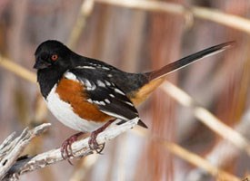
Pipilo maculates A black hood extends down over the back and chest of the Spotted Towhee before giving away to a white and cinnamon chest. The white speckled wings give it its name. Its body is chunky with a long tail, and thick bill.
To reach the seeds and insects of its diet, the towhee, along with other sparrow species, will use a backwards, scratching hop to pull back the earth to expose their meal.
During mating season, the male of the species will spend almost its entire time singing as loud as it can to attract a mate. As soon as a female chooses a male, the bird will refuse to sing anymore, singing only rarely as its attention has shifted elsewhere. They can be found in the thick shrubbery and thickets.
Photo Credit: Steve Ting
Dark-eyed Junco
Miscellaneous
Fall – VC Winter – VC Spring – VC Habitats: 2, 3, 4

Junco hyemalis
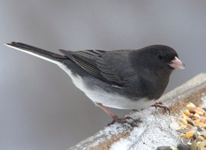
Although their coloring can vary between black, grays, and dark browns, their pattern remains the same: dark upper and white lower. Their beaks are large, thick, and pointed that they use to eat seeds as they forage on the ground.
It is one of the most common birds across North America, living in almost all climates and at extreme elevations, and numbering over 600 million.
Photo Credit: Christopher L. Wood

Song Sparrow
Fall – VC Winter – VC Spring – VC Habitats: 1, 2, 3, 4, 5

Miscellaneous
Melospiza melodia
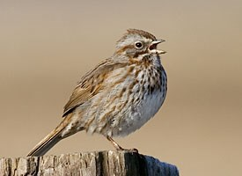
The regional differences in this particular species can be overwhelming, but focusing on key elements can keep identification easy. Look for streaks across the chest and body that cover the brown and gray coloring.
The song of the sparrow, as many other songs, are used for defense and mating. Females of this species take it to the next level, though. They will choose mates based on the complexity of the song as it demonstrates the ability to learn.
Photo Credit: Christine Haines
There are found almost everywhere in North America in woodlands, open fields, near bodies of water. An exceptionally abundant species.
House Finch
Miscellaneous
Fall – C Winter – C Spring – VC Habitats: 2, 3, 4
Haemorhous mexicanus
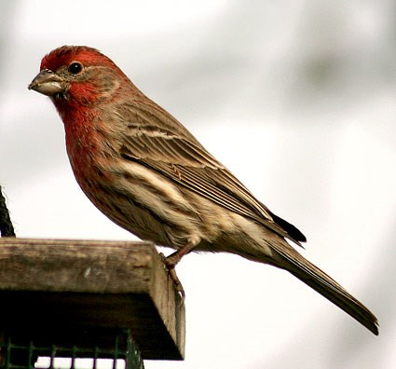
Long necks, small bodies, and thick, rounded beaks are characteristic of this finch. The coloring is very Fall-like, with a warm read head and chest, and a deep brown back. The wings are striated with black and brown. The female of the species is less colored, exhibiting a brown and tan striped coloring all over, looking almost like Douglas fir bark in its grooves.
The red pigmentation in the male is a result of its diet during molting. Females prefer males who have the reddest coloring. This is thought to be because it shows the male’s ability to find and successfully get food. Interestingly the diet is almost exclusively plant material like barks, seeds, and fruits. Their numbers are staggering, with some estimates coming close to 1.4 billion.
Photo Credit: Jeff Hurd
Black-throated Gray Warbler
Miscellaneous
Spring – C Habitats: 3, 4
Setophaga nigrescens
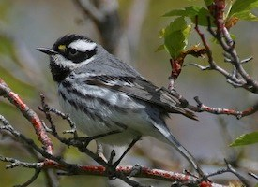
Almost the entire bird is striped: the head, the under chest, and the wings all exhibit the black and white patterning. The one distinguishing feature is the small yellow square in front of the eye that sits above the pointy bill.
They eat primarily insects along the foliage of the understory and canopy.

Photo Credit: Cameron Rognan

Wilson’s Warbler
Miscellaneous
Spring – VC Habitats: 1, 2, 3
Cardellina pusilla
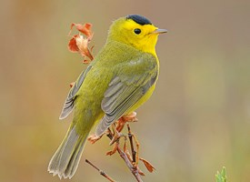
Although it is one of the smallest warblers, its bright yellow and green coloring makes it easy to spot. They have a black cap above the small pointy bill, and gray-tinged wings
They are typically found in the scrub of woodlands and fields, nesting either on the ground or a few feet up. They eat mostly insects, and occasionally drink a sweet excretion of some scale insects on oak trees.
Photo Credit: Gerrit Vyn

Red-breasted Sapsucker
Miscellaneous
Fall – U Winter – U Spring – U Habitats: 2, 3, 4
Sphyrapicus ruber
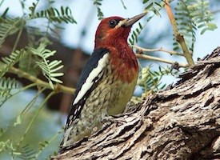
A deep red hood drapes over this unusual woodpecker and white stripe up along its side. They are named for their feeding habits as they drill small holes into trees to reach the sap inside. Sometimes, tinier birds will also use the wells drilled by the sapsucker to reach the sap inside, occasionally relying on it for nourishment.

Photo Credit: Lois Manowitz

Pine Siskin
Miscellaneous
Fall – C Winter – C Spring – C Habitats: 3,4
Spinus pinus
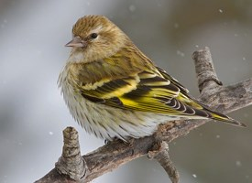
Nomads of the bird world, they will travel to wherever seeds are located. They have brown steaks across their white breast and tan upper. The yellow and black striped wings and tail are the key features.
They are suited for survival with various methods. They can store food in their crop – up to a tenth of their body weight – that can keep them fed and warm through multiple subzero nights. They will also sharply increase their metabolic rate many times over to compensate for the cold.
Photo Credit: Raymond Lee
They love to eat the pine seeds of their local habitats, as their name suggests, but will also feed on other seeds and insects to keep them fed.
Pileated Woodpecker
Miscellaneous
Fall – U Winter – U Spring – U Habitats: 3,4
Dryocopus pileafus
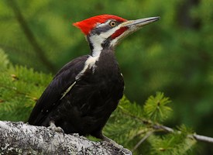
A large red crown boldly tells the world that this is a Pileated Woodpecker. The intense white stripes move down from its face to its black body. It is one of the largest forest birds and woodpeckers, making them stunning finds.
They drill large holes in trees to find larvae and other insects. The holes they leave behind often become the homes of other smaller birds.
It has been recorded that their drilling has been so intense and deep, that smaller trees have actually split in half during the drilling process.
Photo Credit: Gerrit Vyn

